Leonardtown Vol Rescue Squad Auxiliary
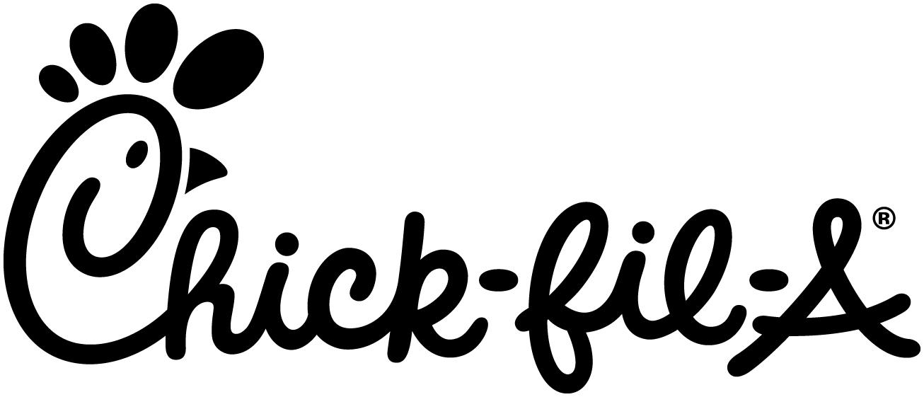
SPIRIT NIGHT
FUNDRAISER
July 23rd
5-7 PM
Place and pay for your order through the CFA ONE app for an extra bonus for your Auxiliary

MUST HAVE FLYER!

Chick-fil-A
First Colony Center

For every 6-count pkg of cookies purchased, an extra $1.40 is added to the fundraising amount. - TONIGHT ONLY
A portion of tonight’s proceeds benefit
...

Leonardtown Vol Rescue Squad Auxiliary
SPIRIT NIGHT
FUNDRAISER
July 23rd
5-7 PM
Place and pay for your order through the CFA ONE app for an extra bonus for your Auxiliary

MUST HAVE FLYER!

Chick-fil-A
First Colony Center

For every 6-count pkg of cookies purchased, an extra $1.40 is added to the fundraising amount. - TONIGHT ONLY
A portion of tonight’s proceeds benefit
...

